DNY-FCBA 2019 Officers and Trustees

President  Joann Sternheimer, Esq.  Deily & Glastetter, LLP  (518) 436-0344 Ext. 4926  Jsternheimer@deilylawfirm.com  8 Thurlow Terrace  Albany, NY 12203 | 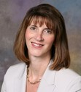
President - Elect  Kimberly M. Zimmer, Esq.  Zimmer Law Office, PLLC  (315) 422-9909  kmz@kimzimmerlaw.com  333 E Onondaga Street  Syracuse, NY 13202 | 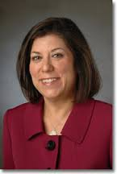
Vice-President (Capital District Chapter)  Adam J. Katz, Esq.  United States Attorney’s Office  (518) 431-0247  Adam.katz@usdoj.gov  United States Attorney's Office  445 Broadway, Room 218  Albany, NY 12207 | 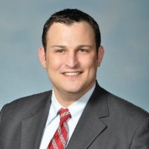
Vice-President (Central New York Chapter)  Eric C. Nordby, Esq.  Porter Nordby Howe LLP  315-477-9912 (direct)  315-477-9900 (main)  enordby@pnhlawyers.com  www.pnhlawyers.com  125 East Jefferson St., 11th Fl.  Syracuse, N.Y. 13202-2550 | 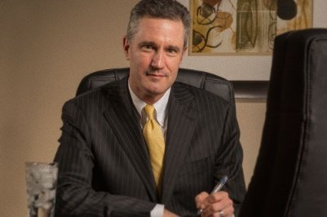
Secretary  Gabriel M. Nugent, Esq.  Barclay Damon, LLP  (315) 425-2836  gnugent@barclaydamon.com  300 South State Street  Syracuse, NY 13202 | 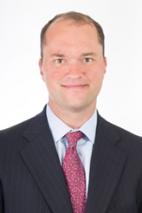
Treasurer  Brian J. Butler, Esq.  Bond, Schoeneck and King PLLC  (315) 218-8160  bbutler@bsk.com  One Lincoln Center, 110 West Fayette Street  Syracuse, NY 13202-1355 | 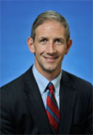
Assistant Treasurer  Molly C. Casey, Esq.  Maguire Cardona  518-434-9807  molly@maguirecardona.com  22 Clinton Avenue  Albany, NY 12207 | 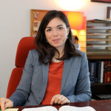

TRUSTEES

Dwight Austin, Esq.  JAG Fort Drum  dwight.e.austin.civ@mail.mil  Legal Assistant Office  Bldg P-10720, Mt. Belevedere Blvd  Fort Drum, NY 13602  (315) 772-5261 | 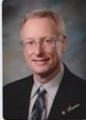
Donald W. Boyajian, Esq.  Dreyer Boyajian LLP  (518) 463-7784  dboyajian@dreyerboyajian.com  75 Columbia Street  Albany, NY 12210 | 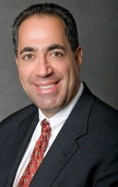
Suzanne Galbato, Esq.  Bond, Schoeneck and King PLLC  (315) 218-8370  sgalbato@bsk.com  One Lincoln Center, 110 West Fayette Street  Syracuse, NY 13202-1355 | 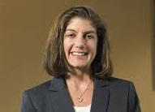
Elena Defio Kean. Esq.  DeFio Kean, PLLC  518-650-7070  edk@defiokeanlaw.com  125 Wolf Road, Suite 108  Albany, NY 12205 | 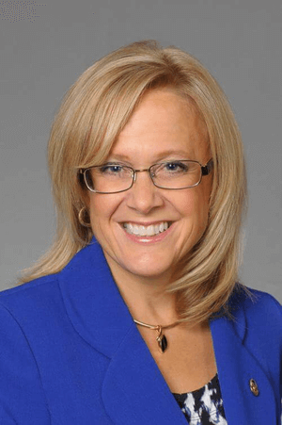
Michael Langan, Esq.  Chambers of Honorable Glenn T. Suddaby  (315)234-8580  Michael_langan@nynd.uscourts.gov  Federal Building, 100 South Clinton Street  Syracuse, NY 13261 | 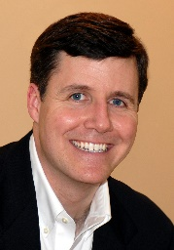
Brian W. Matula, Esq.  State of NY Office of the Attorney General  (518) 776-2599  Brian.Matula@ag.ny.gov  The Capitol  Albany, NY 12224 | 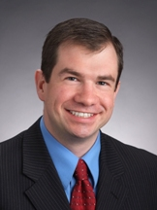
Lorraine Rann Mertell, Esq.
MacKenzie Hughes LLP
(315) 233-8282
lmertell@mackenziehughes.com
P.O. Box 4967
Syracuse, NY 13221

Albert J. Millus, Jr. Esq.  Hinman Howard & Kattell LLP  (607) 231-6724  amillus@hhk.com  80 Exchange Street  Box 5250  Binghamton, NY 13902 | 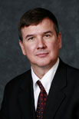
Zachary Oren, Esq.  City of Utica  (315) 792-0171  zoren@cityofutica.com  1 Kennedy Plaza  Utica, NY 13502 | 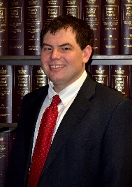
John G. Powers, Esq.  Hancock Estabrook, LLP  (315) 565-4500 Ext. 4547  jpowers@hancocklaw.com  1500 AXA Tower I  100 Madison Street  Syracuse, NY 13202 | 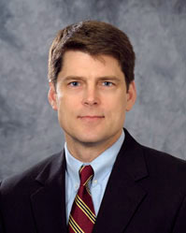

Law School Representatives

Dean Alicia Ouellette
Albany Law School
80 New Scotland Avenue
Albany, NY 12208-3494
(518) 445-3398
aouel@albanylaw.edu

Danshera Cords
Professor
Albany Law School
80 New Scotland Avenue
Albany, NY 12208-3494
518-445-2373
dcord@albanylaw.edu

Elizabeth Peck
Assistant Dean for Judicial Engagement & Professional Development
Cornell Law School
G31 Hughes Hall
Ithaca, NY 14853
(607) 255-9057
ep83@cornell.edu

Dean Craig Boise
Syracuse University College of Law
950 Irving Avenue, Dineen Hall
Syracuse, New York 13244-2130
(315) 443-9580
cmboise@law.syr.edu

For Dean Boise – Always go through his assistant Theresa Coulter tcoulter@law.syr.edu

Lauryn Gouldin, Esq.
Associate Professor
Syracuse University College of Law
950 Irving Avenue, Dineen Hall
Syracuse, New York 13244-2130
(315) 443-9547
lgouldin@law.syr.edu

Kristen Duggleby
Director of Alumni Relations
Syracuse University College of Law
950 Irving Avenue, Dineen Hall
Syracuse, New York 13244-2130
(315) 443-9532
klduggle@law.syr.edu

Past Presidents

Mitchell J. Katz, Esq. (2018)
Barclay Damon
315-474-5810
mkatz@barclaydamon.com

Adam R. Shaw, Esq. (2017)
Boies Schiller & Flexner LLP
(518) 694-4227
ashaw@bsfllp.com

Michael J. Sciotti, Esq. (2016)
Barclay Damon LLP
(315) 425-2774
msciotti@barclaydamon.com

Jeffrey E. Hurd, Esq. (2015)
Burke, Scolamiero, Mortati & Hurd, LLP
518-862-1386
jhurd@bsmhlawfirm.com

Yvonne E. Hennessey, Esq. (2013-2014)
Barclay Damon, LLP
518-429-4293
yhennessey@barclaydamon.com

John P. Langan, Esq. (2014)
Barclay Damon, LLP
315-425-2754
jlangan@barclaydamon.com

Edward R. Conan, Esq. (2012)
Bond, Schoeneck and King PLLC 315-218-8313
econan@bsk.com

Donald T. Kinsella, Esq. (2011)
Kinsella Hoggan LLP
518-312-4176
dkinsella@khlaw.net

Bartle J. Gorman, Esq. (2010)
Principal Law Clerk to Justice Norman I. Siegel
Oneida County Supreme Court Chambers
315-793-2184
bartgorman@roadrunner.com

Michael J. Murphy, Esq. (2009)
Carter Conboy Case Blackmore Maloney & Laird, P.C.
518-465-3484
mmurphy@carterconboy.com

Donald D. Oliver, Esq. (2008)
Blitman & King LLP
315-422-7111
ddoliver@bklawyers.com

William J. Dreyer, Esq. (2007)
Dreyer, Boyajian Law Firm
518-463-7784
wdreyer@dreyerboyajian.com

James H. McGowan, Esq. (2006)
Retired
315-474-7541

Doreen A. Simmons, Esq. (2004-2005)
Hancock Estabrook, LLP
315-471-3151
dsimmons@hancocklaw.com

Executive Director

ShellyAnn Childers
NDNY Federal Court Bar Association
315-422-2799
schilders@ndnyfcba.org

